Crime Trends in New Orleans Between 2018 & 2022

GWU Bootcamp Group Project 1

**Team Members:** Todd Petruska, Francesca Palik, Alexandra de Roos, Nandini Tivakaran

**Submission Link**: <https://github.com/todd-petruska/Group_Project_1.git>

# Project Description

We analyzed trends in crime rates in New Orleans, Louisiana across 2018-2022 to investigate the potential effects of COVID-19 on crime rates.

Research Questions:

How did rates of types of crimes differ across New Orleans districts from 2018 to 2022? In other words, how did rates of types of crime differ across New Orleans districts before, during, and after the COVID-19 pandemic? How did the frequency of overall crimes committed change across districts during the specified time period? What was the distribution of genders across the years?

To answer the above questions, we gathered data from New Orleans police reports between 2018 and 2022 from data.nola.gov. Please note that the data from NOPD is raw data based on preliminary reports and reviews.[1] Therefore, there is a chance for inaccuracy in the data.

# Data Analysis Report

## Manipulation of Data / Cleaning

Five distinct raw datasets are used, one for each year. Records (i.e. rows) represent police reports, and are identified by the column ‘Item Number’. The raw data included multiple records per ‘Item Number’. We found that the first instance of a particular ‘Item Number’ was often the most complete. Repeated lines of that ‘Item Number’ had duplicate values for the columns of interest, and sometimes contained missing values that were previously present in the first instance. For this reason, we kept the first instance of each ‘Item Number’ for our final analytic dataset.[2]

We completed our analytics on each of the final datasets separately by year – including tables with counts, bar graphs, and pie charts. In conclusion, we combined the five years of data for a more focused view of specific crimes and districts, adding additional insight.

## Data Analysis and Visualizations

### Analysis of Crimes by Type

Across the period analyzed, domestic disturbance was the most frequent form of crime across all the districts. From 2019-2022, following the domestic disturbance was the vehicle burglary type. As seen in **Figure 1** and **Figure 2**, vehicle burglary increased most between 2018 and 2019, and increased to nearly the same level of domestic disturbance in 2022, as seen in **Figure 5**.

Figure 1: Crimes by Type 2018

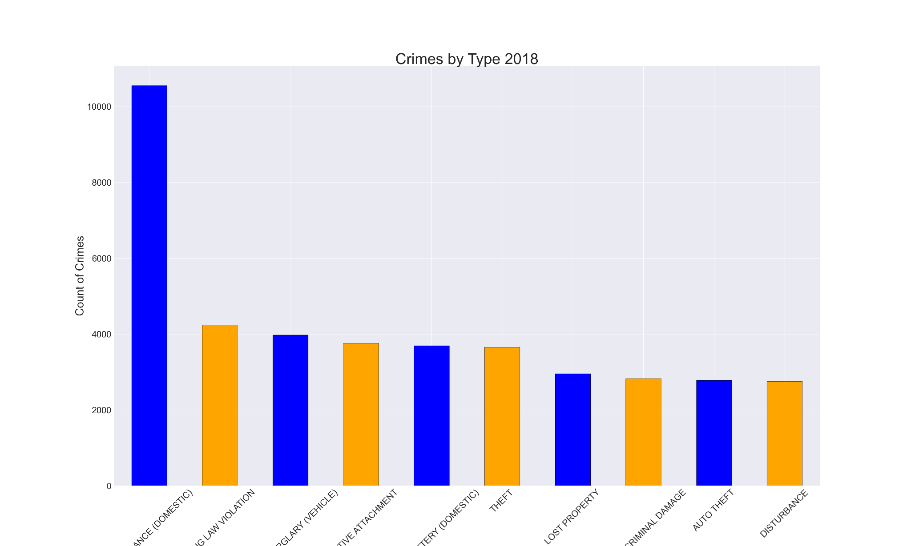

Figure 2: Crimes by Type 2019

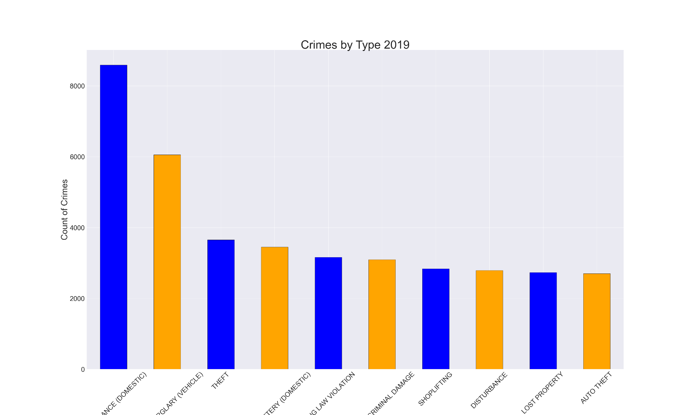

Figure 3: Crimes by Type 2020

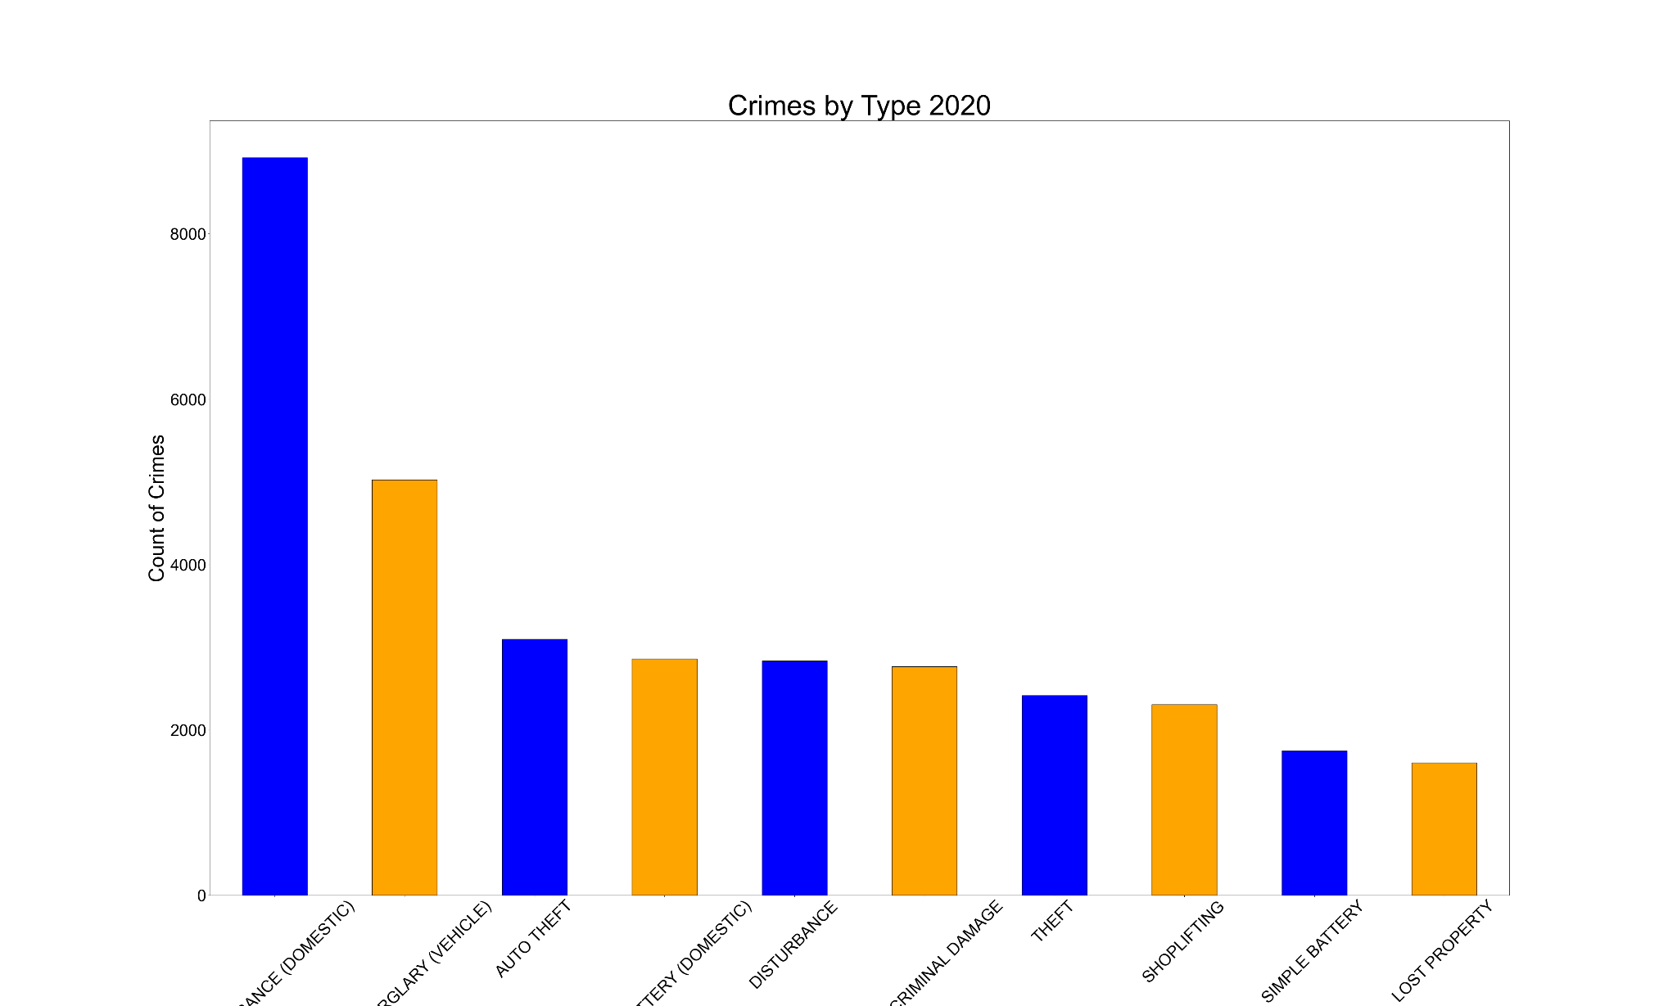

Figure 4: Crimes by Type 2021

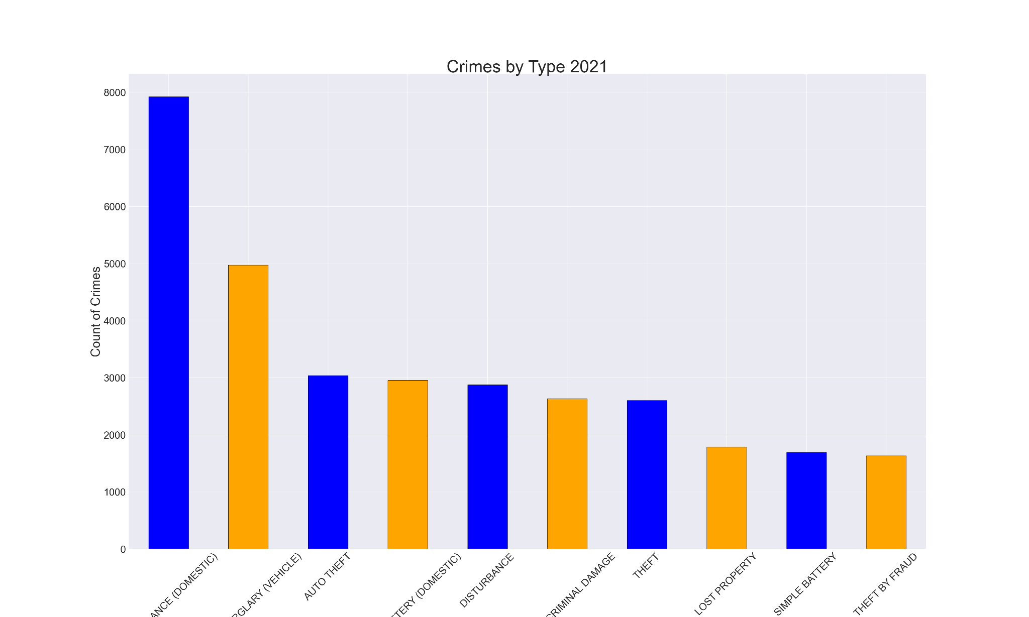

Figure 5: Crimes by Type 2022

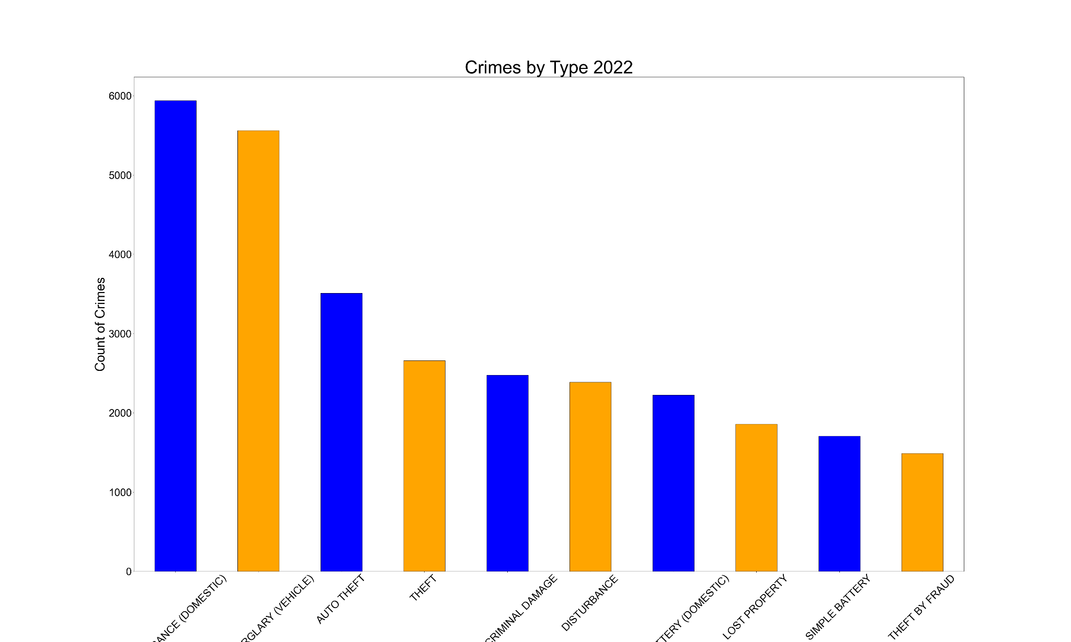

### Analysis of Crimes by District

Our next area of analysis was the frequency of crimes per district. The City of New Orleans is divided into eight field operations districts, each headed by a district captain. For more information about the areas covered in each district as well as district-specific policing programs and information, please refer to this [NOPD webpage](https://nola.gov/nopd/districts/). A map of the districts is included below in **Figure 6**, as a reference for the analysis of the overall frequency of crime across districts.

Figure 6 NOPD: Map of NOPD Field Operations Districts[3]

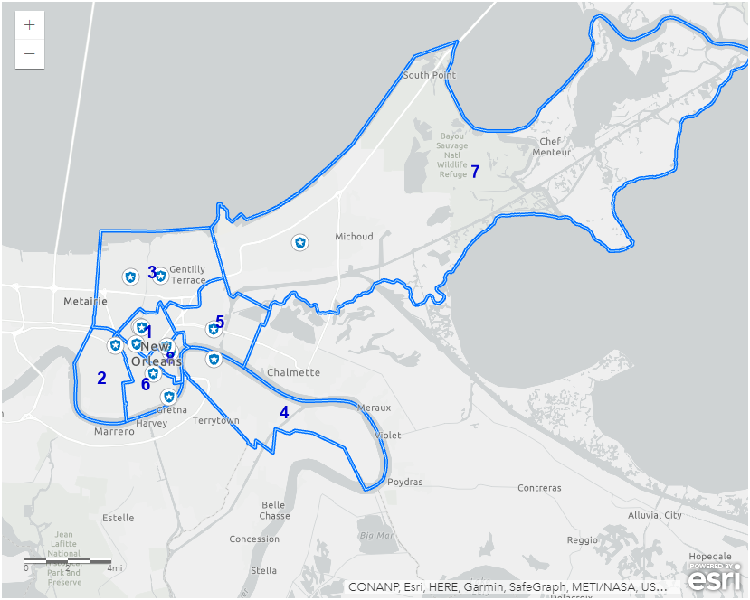

As seen in **Figure 7** and **Figure 8**, In 2018 and 2019, District 7 had the most crimes committed, while District 5 had the third most crimes committed. In 2020, however, that trend changed. District 5’s proportion of crime across the districts increased, and it had the second most crimes committed in 2020 and 2021, as seen in **Figure 9** and **Figure 10**. In 2022, District 5 decreased back to third most crimes committed of all the New Orleans police districts, as seen in **Figure 11**.

In 2018 and 2019, District 8 had the second most crimes committed, but dropped all the way to the lowest number of crimes committed in 2020, as seen in **Figure 9**. The district saw an increase in crime in 2021 and 2022, as seen in **Figure 10** and **Figure 11**. This increase moved it to having the most crimes committed in 2022.

Figure 7: Crime by District 2018

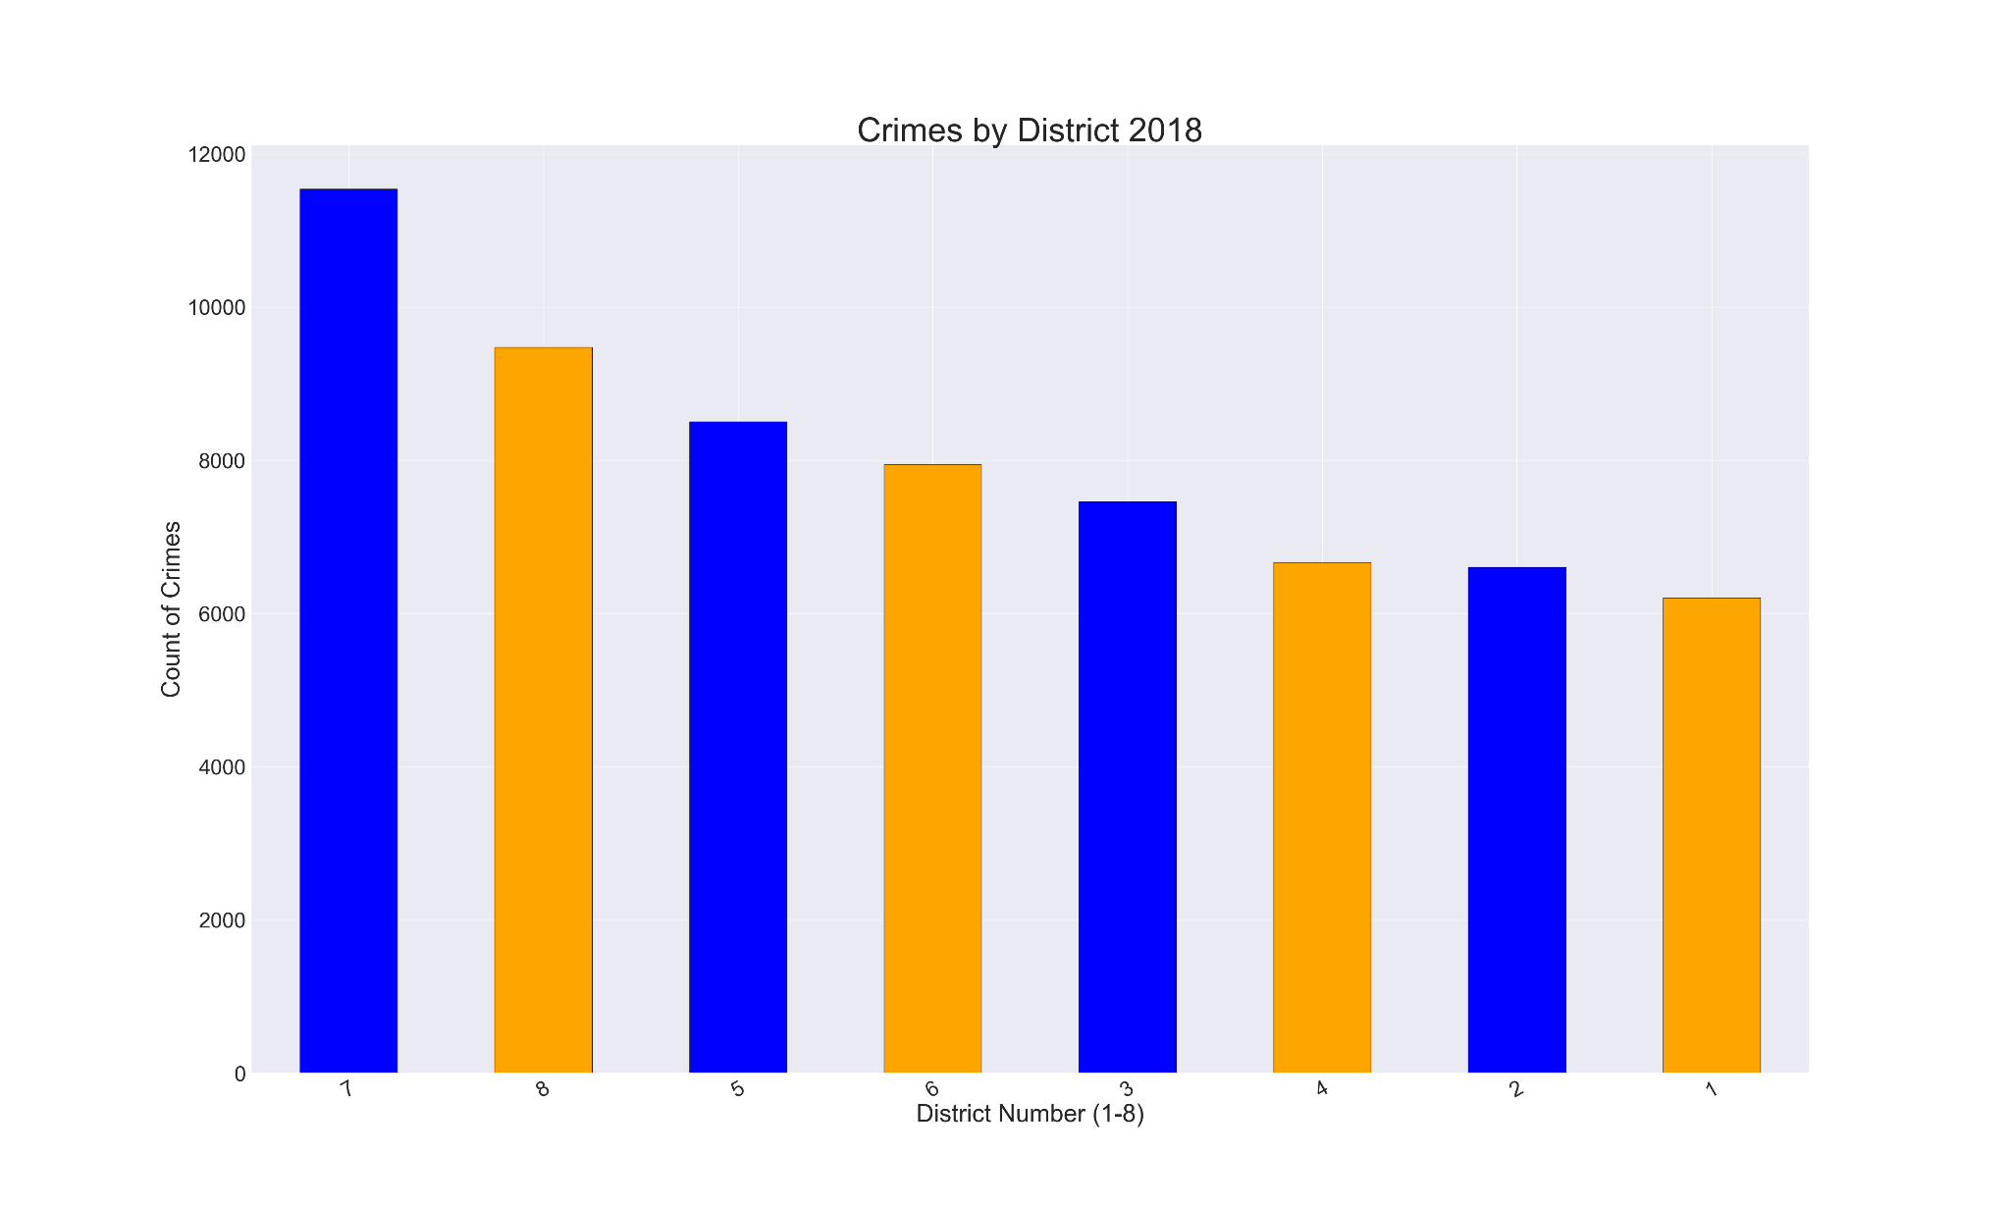

Figure 8: Crime by District 2019

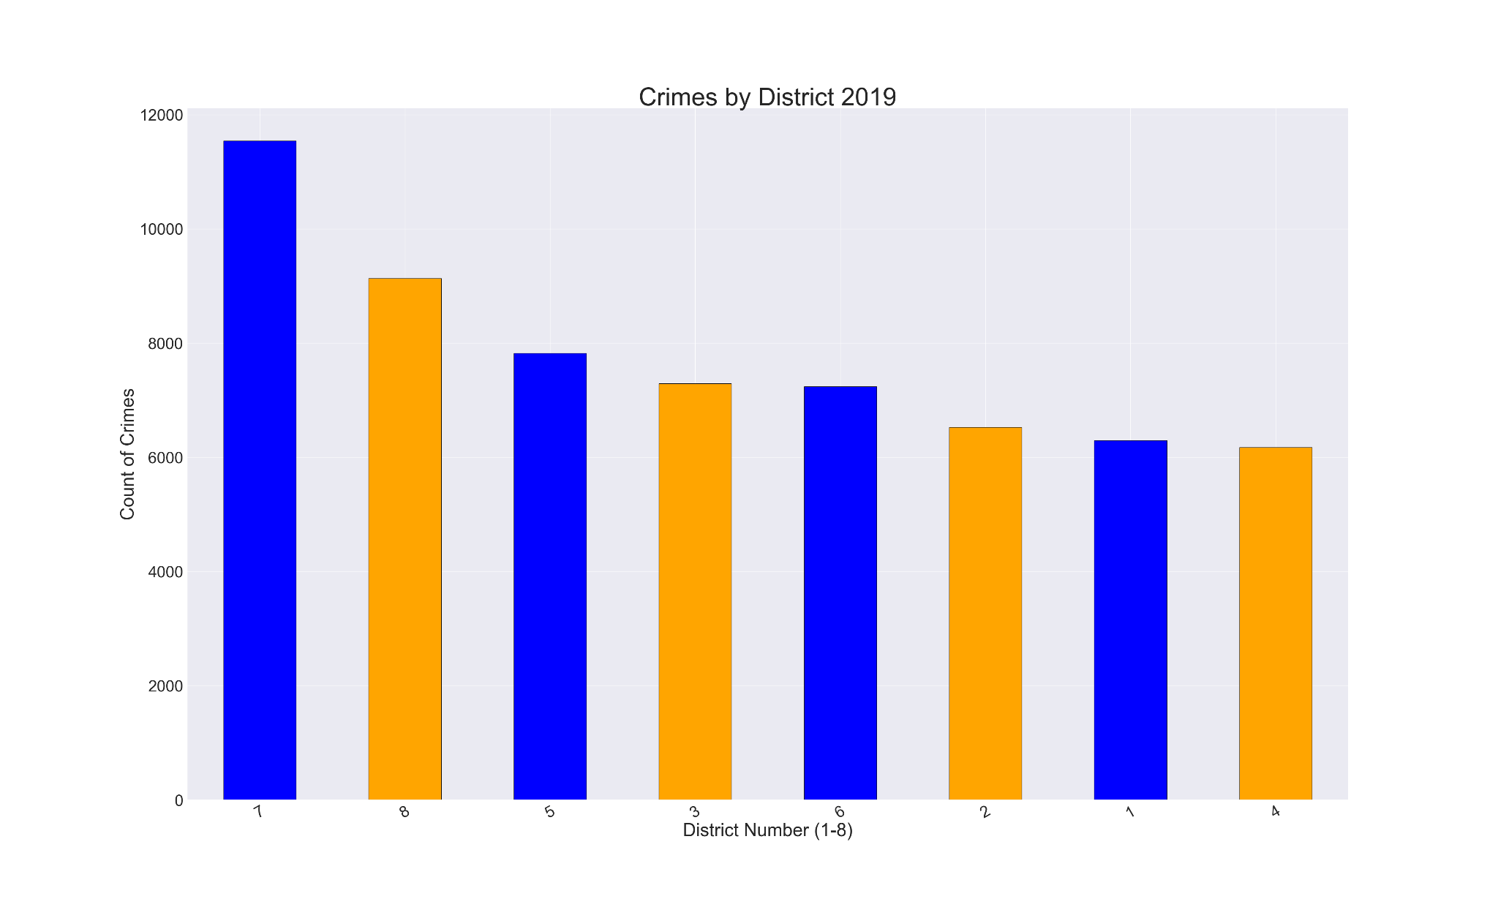

Figure 9: Crime by District 2020

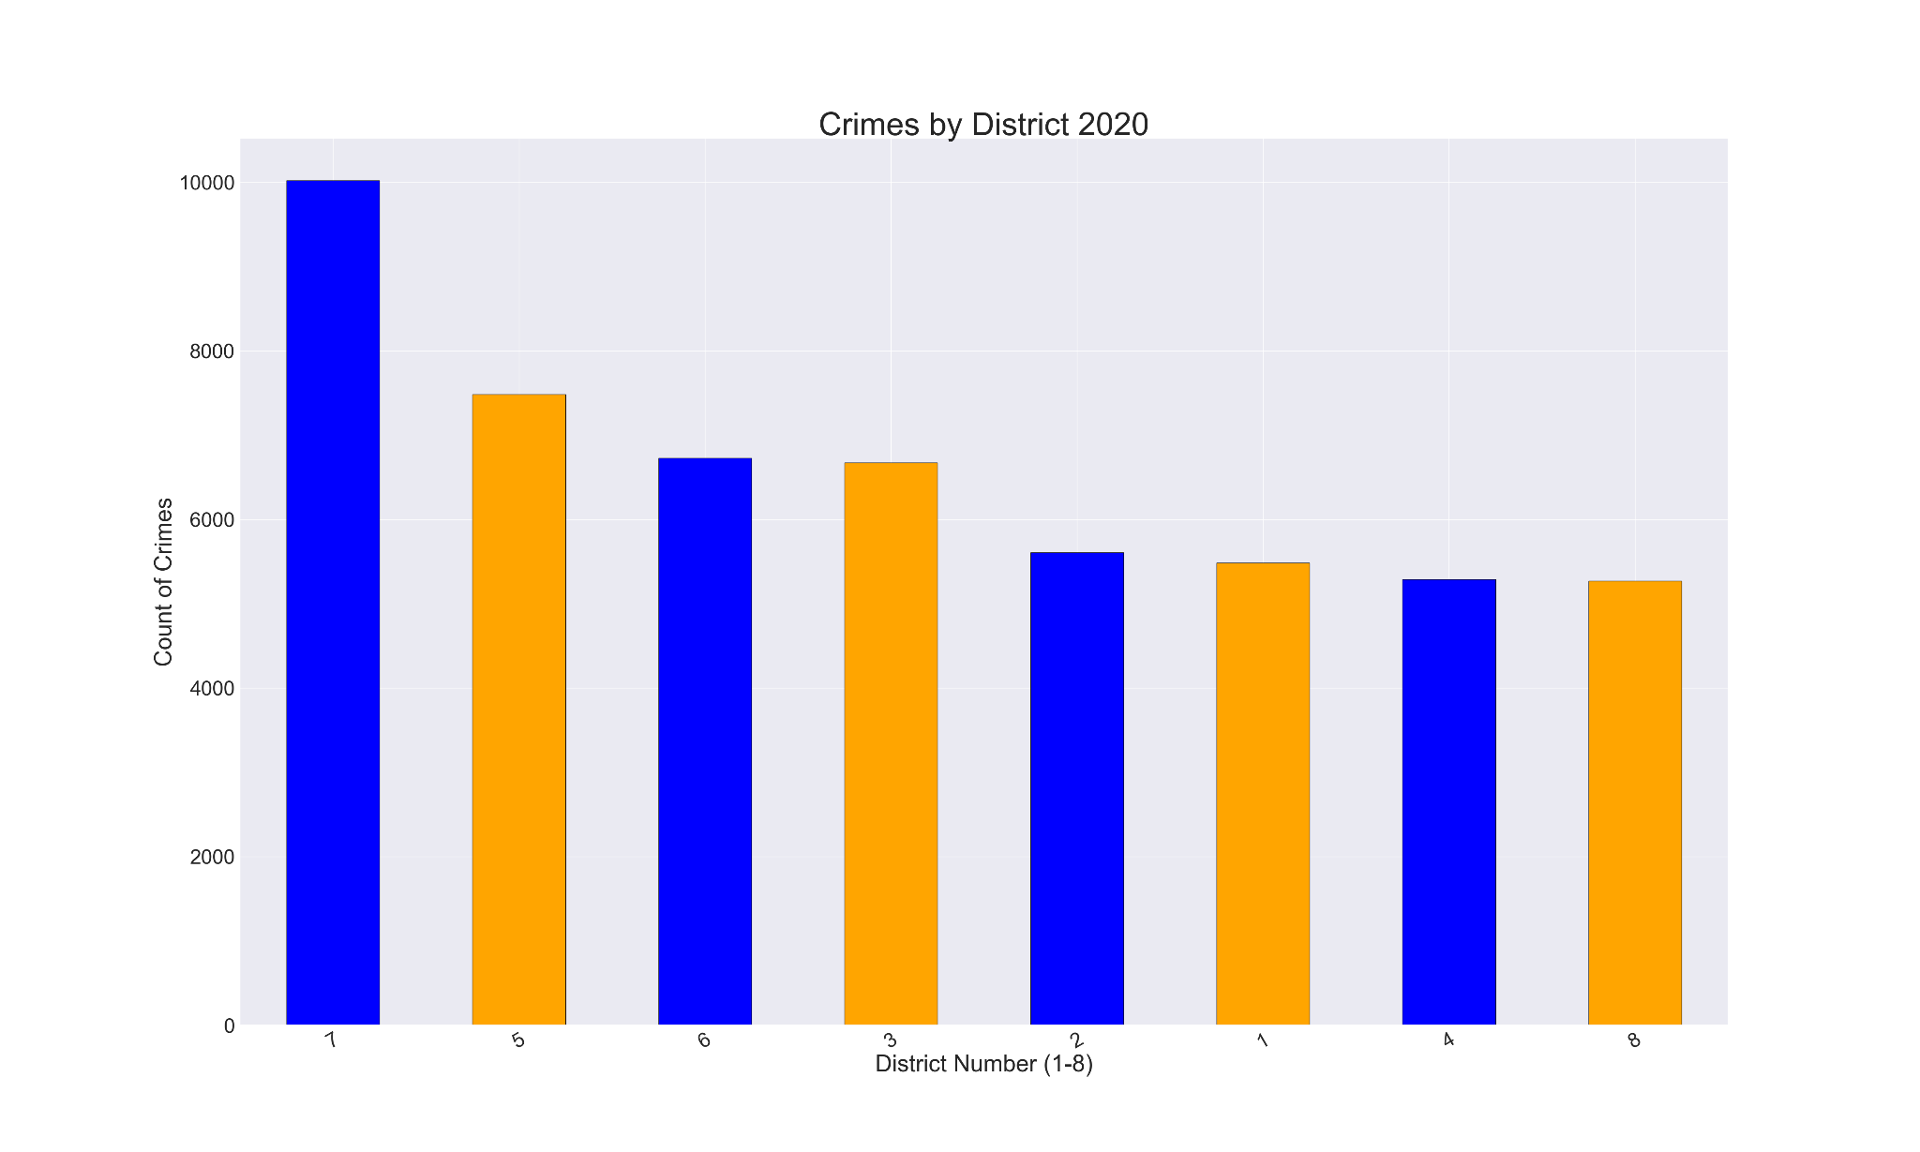

Figure 10: Crime by District 2021

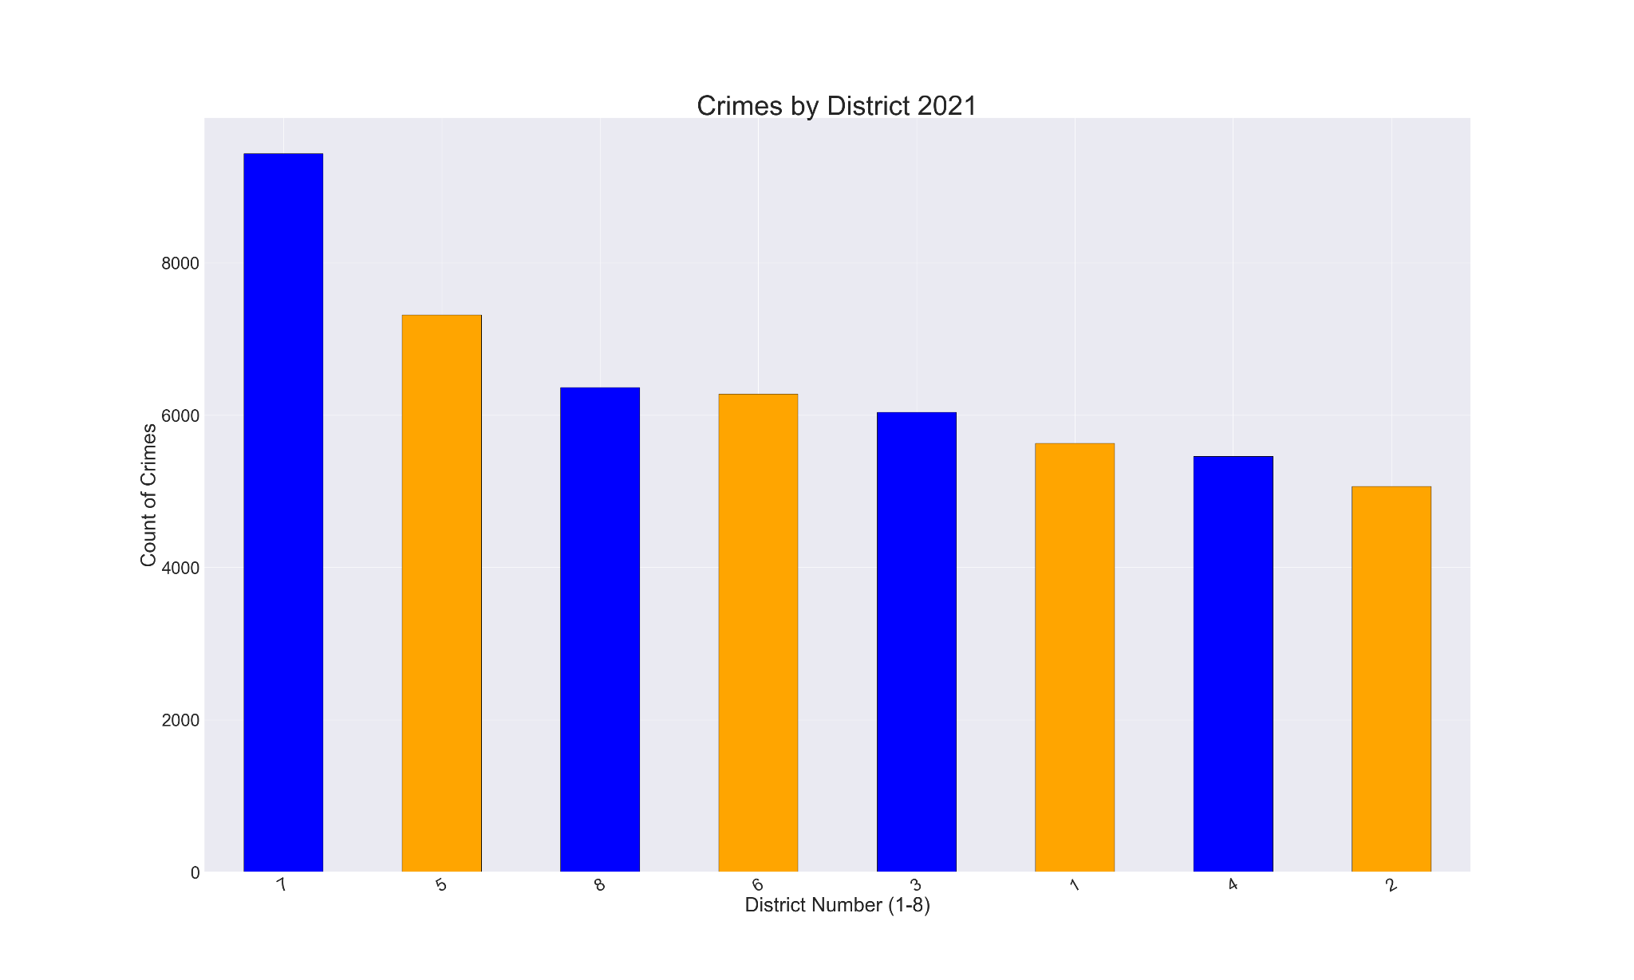

Figure 11: Crime by District 2022

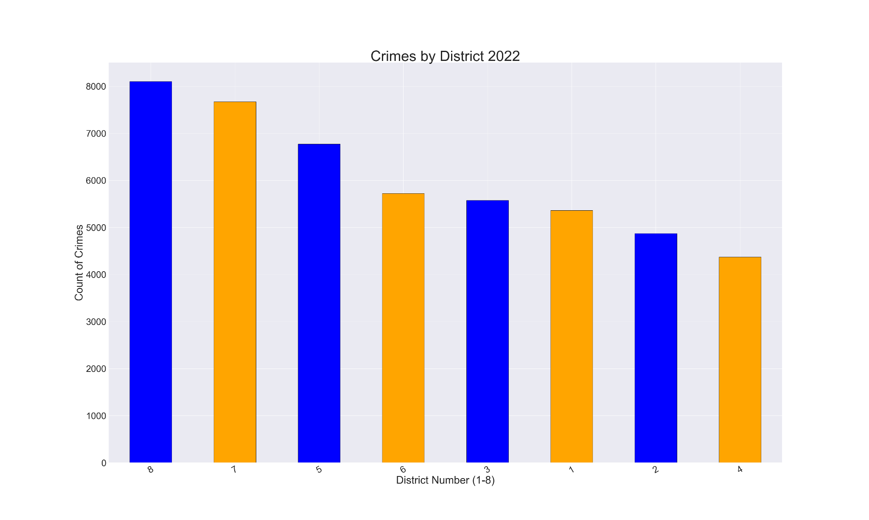

### Analysis of Crime by Gender

In this section, we analyze the distribution of overall crimes committed by gender. In each of the years, more than half of the crimes committed were committed by males. As seen in **Figure 14**, there was an increase in the percentage of crimes committed by males in 2020, the main year of COVID-19.

Figure 12: Crime by Gender 2018

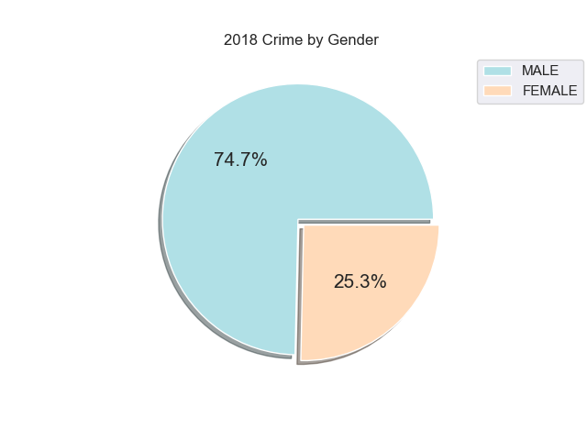

Figure 13: Crime by Gender 2019

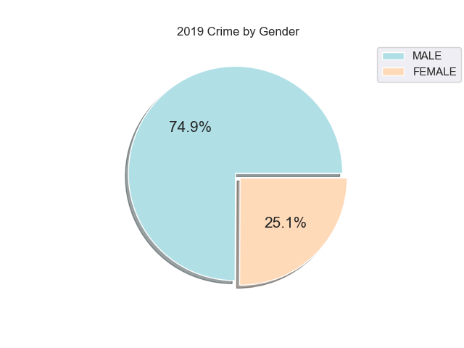

Figure 14: Crime by Gender 2020

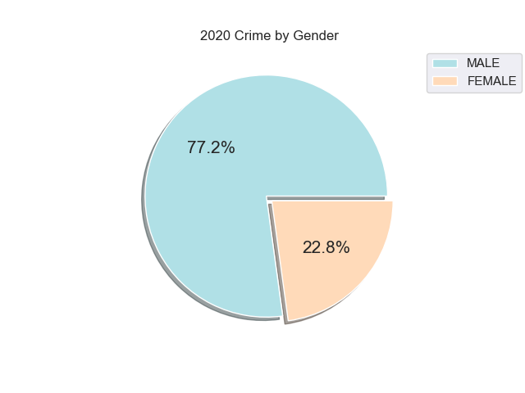

Figure 15: Crime by Gender 2021

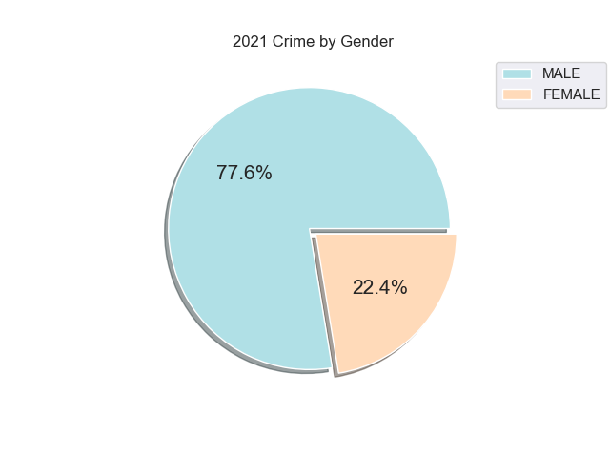

Figure 16: Crime by Gender 2022

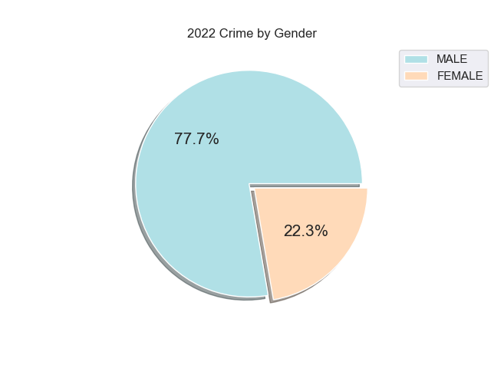

### Analysis Across Years

## Statistical Analysis

Datasets for each year were combined and filtered to determine if there were any trends during the COVID-19 pandemic, which started in the U.S. mid-March 2020, according to Centers for Disease Control and Prevention **(**CDC)’s timeline[4]. The date time group was broken down and evaluated based on year, month, week, day and hour.

Our findings revealed a decrease in criminal events in May of 2020 (4,212), which is a decrease from 2018 (5,700), 2019 (6,037); however, the years 2021 (5,072) and 2022 (4,356) were lower than pre-pandemic numbers for the month of May, as seen in **Figure 13**. The line chart shows a steady decrease during and post COVID-19. District 7 still remained as the predominant volume for filed police reports. The hours appear to remain consistent at 12:00 (1,446) with the highest number of filed police reports, whereas 06:00 (543) is the lowest for the dataset covering for the month of May (2018-2022),as seen in **Figure 14**. Sundays (3,827) remain the highest number of filed police reports, whereas Friday (3,468) is the lowest for the month of May (2018-2022), as seen in **Figure 15**.

Our initial findings revealed a decrease in criminal reporting in the city of New Orleans during COVID-19; however, further analysis is needed to gain a better understanding of criminal activity trends.

Figure 13: Month of May 2018-2022

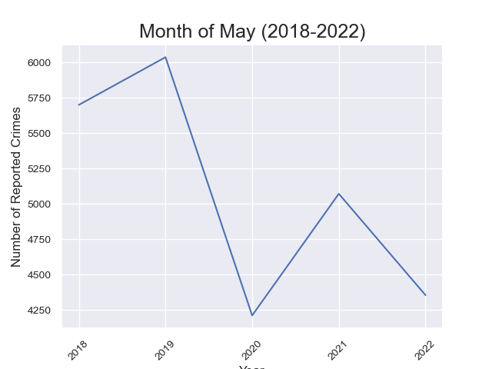

Figure 14: Month of May Hours 2018-2022

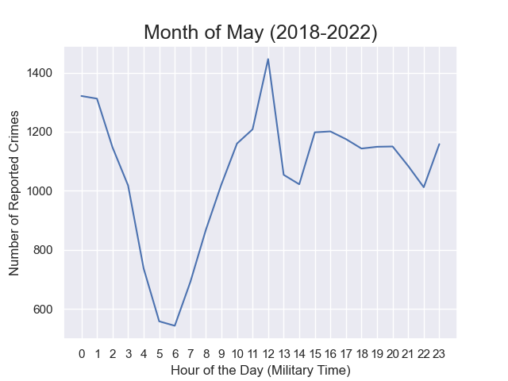

Figure 15: Month of May Days 2018-2022

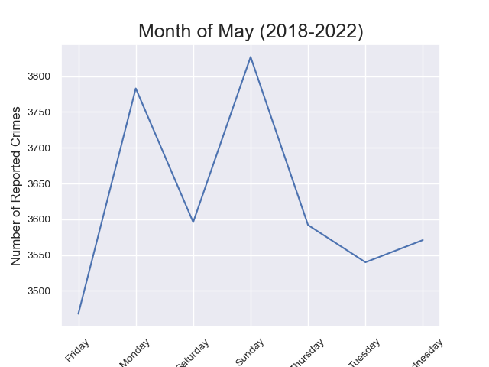

## Conclusions

* In our analysis of the frequency of different types of crimes committed, we found that the top two most frequent crimes across all districts were domestic disturbance and vehicle burglary.
* In our analysis of crimes by district, we saw a few changes in trends across the period studied. District 5 saw a large increase in the number of crimes committed in 2020, which has remained until 2022. District 8, however, saw a sharp decline in the number of crimes committed in 2020. It has since increased, but not to its former 2018 and 2019 levels.
* In our analysis of crime committed by gender, we found a consistent pattern of approximately 70-75% of crimes committed by men across all the years studied. However, in 2020, there was an increase in the proportion of crimes committed by men.
* Overall, crime rates are at their height in 2018 and 2019, and then decrease in the years that follow. This could represent the height of pandemic fears and uncertainty, the beginning of shutdowns, the initial loss of employment and financial stress that manifest at the pandemic’s onset. The decrease starting in 2020 may reflect the beginnings of societal adaptation, the broader access to pandemic ‘assistance resources’, increased access to new treatments and immunization development – all of which easing initial societal stresses that often impact overall crime rate.

## Areas for Future Data Analysis

In the future, we would also perform a time series analysis of the number of crimes per day across each year, to understand in more detail when rates of different crime types increase or decrease.

To understand the impacts of COVID-19, future research could incorporate data from more years prior to the pandemic and after the pandemic. Future research could include more qualitative analysis of the conditions within each district. This information could be used to explain potential causes for the changes in frequency of crime committed across districts.

The addition of census data per district could provide further insight for the number of crimes committed vs. population density for each district.

1. <https://nola.gov/nopd/data/>
2. Note: having a final dataset without duplicate records is of course necessary to provide for accurate counts and overall analytics. We accomplished this programmatically.
3. <https://nola.gov/nopd/districts/>
4. <https://www.cdc.gov/museum/timeline/covid19.html>